

**The state of the financial markets**

Speech given by

Paul Fisher, Executive Director for Markets, Member of the Monetary Policy Committee and interim Financial Policy Committee

Delivered at the Institutional Investor Institute, Bedfordshire 29 June 2011

I would like to thank Ronnie Driver, Andrew Harley, Tanveer Hussain, Ben Wensley, Richard Windram and Chris Young for their help in preparing this speech.

Any views expressed are solely those of Paul Fisher and should not be ascribed to the MPC or FPC unless explicitly stated as such.

The Bank of England has two core purposes. The first is maintaining monetary stability. That means achieving stable prices as defined by the Government and ensuring confidence in the currency. The second is contributing to financial stability. That entails identifying, monitoring, and taking action to remove or reduce systemic risks with a view to protecting and enhancing the resilience of the UK financial system. The interim Financial Policy Committee (FPC) was set up by the Government earlier this year to help meet this objective.1 It has now had its first round of meetings and a record of its first policy meeting and the associated *Financial Stability Report* were published just last week.2

To help meet these objectives, the Bank runs a Market Intelligence (MI) programme, which involves frequent meetings and conversations between Bank staff and a wide range of external market contacts to gather and analyse information from market participants. The Bank is uniquely positioned to run such a programme, given its public policy objectives, its own sterling and foreign currency operations, and its location within one of the world’s foremost international financial centres. Up to 70 Bank staff, the vast majority of whom have other, full-time operational duties, help to collect MI as part of their day-to-day responsibilities. Personally, I estimate that, over the past 6 months, I have been involved on average in two meetings with market contacts every working day. Our external contact base is very extensive,3 internationally diverse,4 and covers a wide range of markets, from vanilla instruments such as gilts and equities through to all manner of derivatives.

This MI programme makes a crucial contribution to meeting the Bank’s core purposes by (partially) making up for missing data (at least qualitatively and occasionally quantitatively) and helping us to understand better the behavioural patterns that underlie movements in financial variables. On the monetary policy side, for example, it can shed light on the drivers of commodity prices and changes in market-based measures of inflation expectations. On the financial stability side, the significant complexities in the financial system, the lack of data and the constantly and rapidly evolving nature of financial markets mean that MI is particularly useful in helping us spot the emergence of stress and new developments and risks that might introduce potential vulnerabilities and fault lines in parts of the financial system.

Today, I want to use the insights gained from our market intelligence work, together with market data, to provide an overall assessment of the state of financial markets, including the extent to which they have recovered since the depths of the financial crisis, the impact of a renewed reach for yield on financial innovation, and the impact of the regulatory agenda on market functioning.

1 For more details, see the Government’s consultation document “*A new approach to financial regulation: building a stronger system”,* available at [http://www.hm-treasury.gov.uk/d/consult_newfinancial_regulation170211.pdf.](http://www.hm-treasury.gov.uk/d/consult_newfinancial_regulation170211.pdf) The interim FPC’s terms of reference can be found at [http://www.bankofengland.co.uk/financialstability/fpc/termsofreference.pdf.](http://www.bankofengland.co.uk/financialstability/fpc/termsofreference.pdf)

2 Both documents are available at <http://www.bankofengland.co.uk/financialstability/fpc/meetings/index.htm>

3 Including, for example, the major commercial and investment banks, major wholesale dealers, second-tier banks, brokers, platform

providers, corporate treasurers, asset managers, pension funds, insurance companies, hedge funds, private equity funds and many more risk managers, speculators, hedgers and end investors.

4 We meet contacts in all the major financial sectors, including London, New York, Boston and the Far East.

# The evolution of financial markets during the crisis

To set the scene, it is instructive to look at the general pattern in markets over the past few years. **Chart 1** uses a ‘heat-map’ to summarise data on issuance and spreads in primary and secondary markets for selected bonds and asset-backed securities (ABS), compared to their historical averages. The widespread panic and financial market seizure of 2008 is clearly visible in the concentration of red and grey segments. The latter represent those periods in which there was no primary issuance or spread data because the markets were effectively closed.

Chart 1: Market functioning ‘heat map’ based on issuance and spreads data(a)

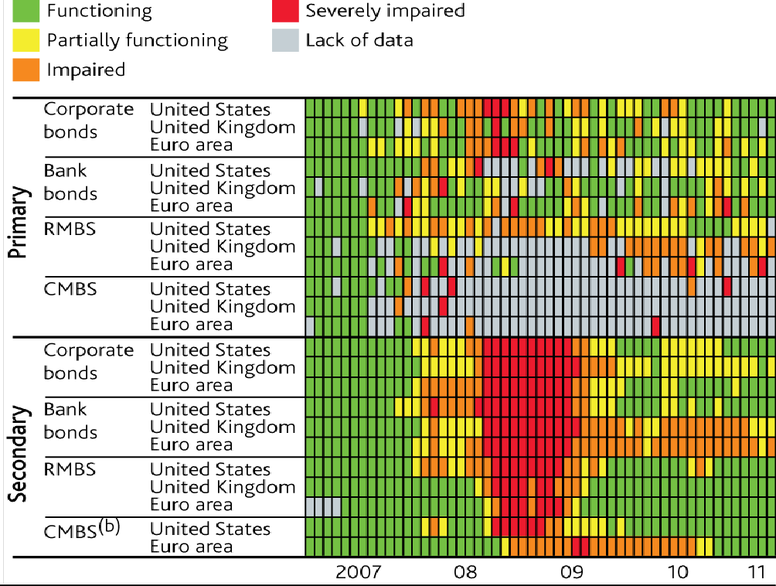

Sources: Bank of America Merrill Lynch Global Research, Bloomberg, Dealogic, JPMorgan Chase & Co. and Bank calculations.

1. Shading is based on a score that reflects, for unguaranteed debt, both issuance (relative to GDP) and spreads in primary markets and secondary markets, expressed as a number of standard deviations from average, using as much data as was available from January 1998. Updated to end- May 2011; recent months use 2011 Q1 GDP.
2. Insufficient data for UK CMBS secondary markets.

Since the nadir in late 2008, most markets have been on a course of gradual healing. The heat map shows how issuance and spreads in these particular markets have recovered. Advanced economy corporate bond spreads have fallen back sharply since their peaks (**Chart 2**). Measures of volatility and bid-offer spreads across a range of asset classes have also fallen back since the height of the disruption (**Charts 3 and 4**).

And most international equity indices have picked up markedly since their troughs (**Chart 5**).

Chart 2: Advanced economy corporate bond spreads(a)

Basis Points

1000

Non-investment grade

Basis Points

2500

900

800

700

600

500

400

300

200

100

0

corporates (RHS)

2000

Investment grade corporates (LHS)

1500

1000

500

0

2005 2006 2007 2008 2009 2010 2011

Sources: Bank of America/Merrill Lynch.

(a) Option-adjusted spreads over government bond yields.

Chart 3: Implied volatilities in selected markets(a)(b)

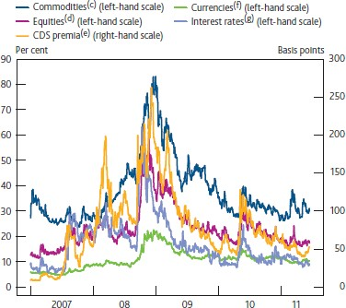

Sources: Bloomberg, British Bankers’ Association, Chicago Mercantile Exchange, Euronext.liffe, JPMorgan Chase & Co. and Bank calculations.

1. Three-month option-implied volatilities.
2. Data to close of business on 14 June 2011.
3. WTI crude oil.
4. Average of FTSE 100, S&P 500 and Euro Stoxx 50.
5. Average of five-year on-the-run iTraxx Europe main and CDX North America investment-grade.
6. Average of USD/EUR, EUR/GBP and USD/GBP.
7. Average of three-month short sterling, euro-dollar and Euribor.

Chart 4: Bid-ask spreads on selected assets(a)(b)(c)

Indices: January 2005 = 100

1400

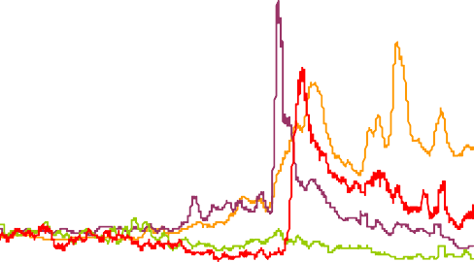

Corporate bonds Government bonds

Equities (d)

Commodities Currencies Interest rate swaps

1200

1000

Chart 5: International equity prices(a)

800

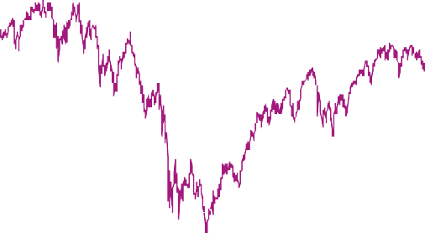

Indices: 2 January 2007 = 100

120

110

100

90

80

70

Euro Stoxx

FTSE All‐share

S&P 500

TOPIX

60

50

40

2007 2008 2009 2010 2011

600

400

200

0

2005 2006 2007 2008 2009 2010 2011

Sources: Bloomberg, UBS Delta and Bank calculations.

1. Monthly moving averages of daily bid-ask spreads.
2. iBoxx € Corporates for corporate bonds; S&P 500 for equities; iBoxx € Sovereigns for government bonds; sterling/dollar exchange rate for currencies; gold price for commodities; and euro five-year swaps for interest rate swaps.
3. Data to close of business on 10 June 2011.
4. End of day bid-ask spread until 1 May 2011, average intra-day bid-ask spread thereafter.

Sources: Bloomberg, Thomson Reuters Datastream and Bank calculations.

(a) Denominated in units of local currency.

This recovery in markets has been neither uniform nor smooth. For example, a number of markets were severely disrupted by concerns about the debt sustainability in Greece, Ireland and Portugal in mid 2010, and once again during 2011 (**Charts 6 and 7** show these countries’ bond spreads to German Bunds and sovereign CDS premia). And a number of private sector markets, such as the ‘own label’ US residential mortgage-backed securities (RMBS) market and the UK commercial mortgage-backed securities (CMBS) market have seen very little, if any, primary issuance since the crisis. 5 In part that reflects continued weakness in commercial real estate and (to a lesser extent) residential housing markets. But it is also likely to reflect the combination of a large existing stock of ABS and a diminished investor base as many of the funding mechanisms have been swept away. These factors have slowed the recovery in primary issuance, and suggest that ABS markets are likely to be much smaller in future. Indeed some markets that were at the epicentre of the crisis, such as those for structured collateralised debt obligations (CDOs), may be permanently gone.

Chart 6: 10-year sovereign bond yield spreads to German Bunds

Chart 7: Selected European sovereign CDS premia

Basis points 2000

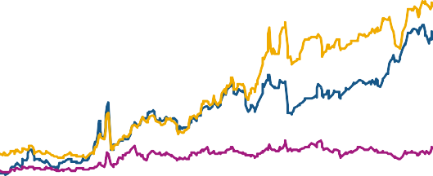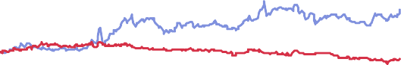

Basis points

1400

Portugal

Ireland

Spain

Italy

Greece

United Kingdom

1200

1000

800

600

400

200

0

Jan. Mar. May. Jul. Sep. Nov. Jan. Mar. May.

2010 2011

Ireland Italy

Portugal

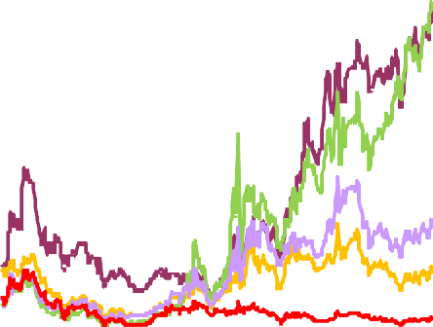

Basis points

800

1800

1600

1400

1200

1000

800

600

400

200

0

Spain

UK

Greece (LHS)

700

600

500

400

300

200

100

0

Jan. Apr. Jul. Oct. Jan. Apr. Jul. Oct. Jan. Apr.

Sources: Bloomberg and Bank calculations.

2009 2010

Source: Thomson Reuters DataStream

2011

Despite a number of shocks along the way, markets have been increasing in their resilience over the past two years. For example, UK banks have been able to continue to issue debt in both public and private markets during 2011, in spite of renewed sovereign debt concerns, the natural disasters in Japan and civil unrest in the Middle East and North Africa.6 Moreover, that issuance has been spread across an increasingly diverse range of instruments including, more recently, UK RMBS (**Chart 8**). This has helped the UK banks alleviate concerns about the ‘funding cliff’ of official sector refinancing at the end of 2011. For example, it has facilitated the remarkable pre-emptive reduction in the amount outstanding under the Bank’s

5 Just in the past couple of weeks we have seen the first European CMBS to be issued since August 2007. In the United Kingdom, some corporates have issued long-dated fixed-rate bonds secured on real estate as part of sale and leaseback transactions. Market participants, however, tend to regard these transactions as corporate debt, rather than CMBS.

6 Market intelligence suggests that the major UK banks have raised around £25bn in private markets in the year-to-date 2011.

Special Liquidity Scheme (SLS), from around £90bn at end-February to just £37bn at the end of May (**Chart 9**).

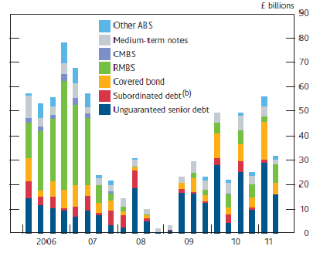Chart 8: Major UK banks’ unguaranteed term issuance in public markets(a)

Sources: Bank of England, Dealogic and Bank calculations.

1. 2011 Q2 is up to and including 15 June 2011. Term issuance refers here to securities with original contractual maturity or earliest call date of at least 18 months. This excludes debt issued under HM Treasury’s Credit Guarantee Scheme.
2. It includes subordinated lower Tier 2 and Tier 3 capital instruments with debt features.

Chart 9: Aggregate SLS repayment profiles

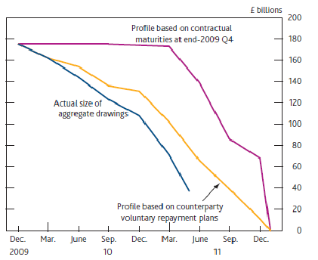

Chart 10: Credit Default Swap premia(a)(b)

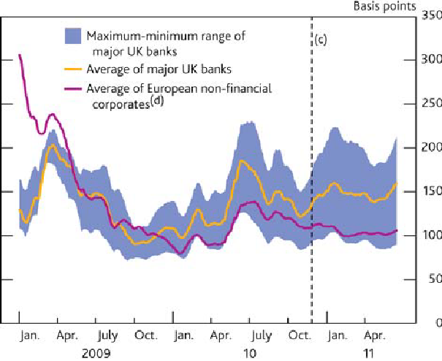

Sources: Bloomberg, Markit Group Limited and Bank calculations.

* 1. Five-year senior CDS premia. Data are presented as fifteen-day end-period moving averages.
  2. Chart shows data for a subset of the major UK banks peer group — Barclays, HSBC, LBG and RBS.
  3. December 2010 *Financial Stability Report*.
  4. Average of the CDS premia of companies that were part of the iTraxx European non- financial corporates index (series 10) at the beginning of the time series in this chart.

But this is no time for complacency. UK bank funding costs, as proxied by their CDS premia, remain elevated – both relative to their historical average, and relative to European non-financial corporations’ CDS premia (**Chart 10**). And there remain significant risks going forward. Sovereign strains, and their potential impact on the European banking sector in particular, represent the most immediate and material threat to markets generally and to UK financial stability. As a result, the interim FPC have recommended that the major UK banks provide improved and more comprehensive disclosure of their sovereign and banking sector exposures. There is also event risk associated with the forthcoming publication of the EBA stress test results, if the results are markedly different from market expectations.

# The search for yield/assets

The significant recovery in many global financial markets reflects, in part, the actions of policymakers around the world. In the United Kingdom, the Bank of England responded to the collapse in economic activity and the risk of deflation by cutting official interest rates and embarking on a programme of asset purchases financed by the creation of central bank reserves (known as Quantitative Easing). It also separately sought to stimulate markets for corporate debt and commercial paper, and put in place a Special Liquidity Scheme for banks to swap their illiquid collateral for highly liquid T-bills. Other central banks took a variety of similar actions. For example, the Federal Reserve began purchasing a range of private and public sector securities in large scale. And in Europe, the ECB responded by offering its counterparty banks unlimited refinancing operations at maturities of up to 12 months.

Despite these differences in policy, one end result was common – they led to a massive expansion of central bank balance sheets (**Chart 11**) and a significant injection of liquidity into the global financial system. That in turn pushed down yields on ‘safe’ assets, encouraging portfolio rebalancing (one of the key channels through which asset purchases work) and a ‘reach for yield’.7

More recently contacts, especially those in the United States, have reported that the reach for yield has been exacerbated by a perceived reduction in the universe of acceptable assets for real money investors.8 For example major corporates, especially those in the United States, are reported to be relatively cash rich. Flow of funds data suggest that the US corporate sector is holding around $1trn – or 7% of total corporate sector financial assets – in cash. That has led to a reduction in US investment grade net bond issuance and an associated shortage of high-quality corporate assets, at a time when relative demand for those assets is strong. And there has also been a reduction in US T-bill issuance, amid ongoing concerns about the extension of the US government’s debt ceiling. Similarly, serious concerns about the creditworthiness of a number of euro-area sovereign issuers have led to a reduction in the quantum of euro-denominated assets perceived to be ‘safe’, with some US money funds reducing their exposures to European banking sectors.

7 As described by Janet Yellen in her recent speech “Assessing potential financial imbalances in an era of accommodative monetary policy”.

8 For an interesting academic exposition of this ‘macroeconomic shortage of assets’, see Caballero, R, “A Caricature (Model) of the World Economy”, available at <http://papers.ssrn.com/sol3/papers.cfm?abstract_id=1724897>

And a number of other structured and synthetic assets, which had been rated AAA prior to the crisis, have recently been shown to be unworthy of that accolade.

Chart 11: Central bank balance sheets

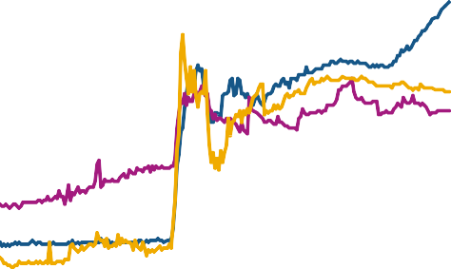

£ billions

350

Local currency billions

3000

300

2500

250

2000

200

1500

150

1000

100

Fed (right-hand scale)

50

500

0

ECB (right-hand scale) BoE (left-hand scale)

0

2007

2008

2009

2010

2011

Sources: Bloomberg and Bank of England.

Chart 12: US, UK and Euro area GDP

Sources: ONS, Eurostat and Bureau of economic analysis.



Indices: 2008 Q1 = 100

102

100

98

96

94

92

United Kingdom

Euro area

United States

2004 2005 2006 2007 2008 2009

90

88

86

84

2010 2011

It is still early days, but the combination of portfolio rebalancing and this reported shortage of specific high-quality assets might have wider implications for financial stability if it encourages investors to look for

additional yield by moving into more illiquid products (by investing in new asset classes or in derivatives of more liquid underlying instruments) or into more complex products (which they might not fully understand, and which might not be appropriately priced for correlation, optionality or underlying credit risk). Market intelligence is crucial here, in that it can provide us with near real-time information about whether and where these risks might be building (or eventually crystallising).

So far, there is little evidence of excessive risk-taking on a generalised basis across the financial system.

But the intelligence we have gathered during 2011, notwithstanding the recent pull-back in June, has flagged a number of pockets of increasing risk appetite and a few specific markets which have been showing signs of excess. That tendency seems to have been most prevalent in the United States, where the financial and real economy recoveries appear somewhat more established than in the UK and the euro area (**Chart 12**). But during recent discussions, some market participants have noted that this tendency has begun to spread to Europe as well.

One example comes from the high-yield corporate bond markets, where demand has been very strong and where issuance, which reached record levels in 2010, has continued apace in 2011 (**Chart 13**). That is likely to reflect the generalised disintermediation of stricken banking systems – for those that are able to tap capital markets, bond issuance poses a useful alternative to bank lending. Moreover the extent of high-yield

issuance may reflect the fact that it is smaller businesses, which are likely to be sub-investment grade, who are finding it hardest to secure affordable bank finance.9 Given oligopolistic banking systems like those in the UK, a deeper and more liquid capital market might help improve the supply of credit to UK businesses. Indeed, recent MI has suggested that there has been some direct lending activity to mid-sized corporates in the UK by non-bank institutions such as dedicated loan, private equity and pension funds (although the absolute amounts are still very small).

Chart 13: Issuance of sub-investment grade corporate debt by region(a)(b)

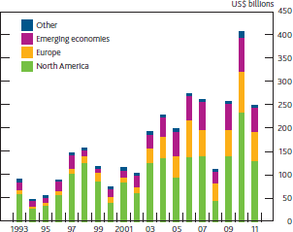

Sources: Dealogic and Bank calculations.

1. Emerging economies includes Africa, Caribbean, Indian subcontinent, Latin America, Middle East, North Asia and South East Asia. ‘Other’ includes Australasia and Japan. Includes issuance in all currencies.
2. 2011 data are to 3 June 2011

Chart 14: Corporate bond valuation measure(a)(b)

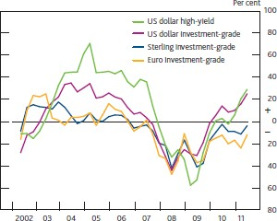

Sources: Bank of America Merrill Lynch, Bloomberg, Thomson Reuters Datastream and Bank calculations.

1. Shows the difference between actual and estimated equilibrium spreads as a percentage. Positive numbers represent overvaluation, negative numbers undervaluation.
2. Equilibrium corporate bond spreads are defined as the total estimated credit component plus a five-year rolling average of the illiquidity premia. Full details of the approach used for the decomposition of corporate bond spreads can be found in Churm, R and Panigirtzoglou, N (2005), ‘Decomposing credit spreads’, Bank of England Working Paper no. 253.

The Bank’s model-based estimates suggest that US high-yield and investment grade corporate debt currently reflect historically low risk premia, and so may be vulnerable to a correction (**Chart 14**). Moreover although much of the recent issuance reflects refinancing of existing bonds or loans (with companies seeking to lock in low interest rates and extend maturities) and M&A activity, there have also been growing reports of US issuance to finance ‘dividend recapitalisations’ (where debt is issued to pay special dividends). Issuance of covenant-lite leveraged loans (which include fewer of the usual protective covenants for the benefit of the lending party) was $34bn in the first five months of 2011, compared with $8bn in the whole of 2010. And US contacts have reported renewed issuance of bonds with Payment-in-Kind (PIK) toggles (where issuers have the option of deferring cash interest payments, choosing instead to roll interest payments into additional debt securities). Although the incidence of these sorts of deals remains significantly below that associated with

9 And although the aggregate US corporate sector cash position is strong, it is likely to mask significant heterogeneity in the distribution of firms, with a disproportionate share of the cash held by the largest investment grade businesses.

the pre-crisis exuberance, these examples might be indicative of the reach for yield/assets encouraging investors to chase returns via higher risk assets.

Despite the low-yield environment, market contacts have been telling us that some investors’ expectations of returns were little changed by the crisis, reflecting a combination of investor inertia and the need to earn sufficient returns to cover their liabilities. But we also hear that investment horizons are often shorter and tolerance of volatility and desire for leverage is lower. Something clearly has to give here – investors know – and must remember – that there is no such thing as a free lunch, and that additional return involves additional risk. The macro-prudential concern is that the reach for yield encourages financial innovation and growth in some parts of the financial system where the risks are not well understood,10 especially if it leads to greater interconnectedness within the banking system. This is one area which is likely to warrant further attention and analysis by the FPC in due course.

# Financial innovation and the emergence/growth of new products

The financial industry is characterised by its tendency to innovate, continuously designing and offering new financial products to its customers. In my view, financial innovation should be seen as a ‘good thing’ in normal circumstances. It can lead to a more efficient allocation of capital and a reduction in the costs of financial intermediation, both of which should help sustain real economic growth. For example, the rapid growth of electronic trade execution in the foreign exchange market has increased the speed and ease with which trades can be conducted. That should ultimately make international trade cheaper, bringing with it the associated benefits. Improvements in technology can, by facilitating wider market access, also lead to improved price discovery and market liquidity. Moreover, innovation can help issuers align the risk characteristics of new products more closely to those that investors demand. In principle, that should promote greater and more efficient sharing and spreading of risk across the financial system. In essence, the recession which followed the financial crisis demonstrated how much the real economy depends on an efficient, functioning financial system.

Financial innovation is a continuous process, and there are many examples of either new products or rapid growth in fashionable markets during the past few years. For example during 2010, there were significant developments in bank funding instruments such as putable CDs and evergreen repos.11 These products offer higher returns to investors compared with more conventional instruments, and also improve banks’ ability to meet new regulatory rules. There has also been an increase in the prevalence of long-term collateral upgrade trades where, for example, a real money investor lends a bank gilts against less liquid but higher yielding assets. Those repo transactions help the real money investor achieve a higher return, while banks build up their liquid asset buffers and fund their less liquid collateral. In that regard, these repo

10 That could come about not only through the low yields on safe assets, but also through an increase in the correlation amongst safe assets, which might prompt reserves managers to seek new diversification opportunities, some of which might be met through financial engineering.

11 These products are discussed in more detail in the box on pages 168-169 of the 2010 Q3 Quarterly Bulletin.

transactions look quite similar to a private sector version of the SLS. Where appropriate, such transactions can both improve the returns to pension funds and support lending to the real economy. Of course, the authorities need to monitor the extent to which these transactions strengthen the links between the banking and insurance sectors. And it is vital that the insurers fully understand the counterparty credit risk they are running, the quality of the collateral they are taking and how to manage the collateral in the event of default.

The more recent developments in markets for Exchange Traded Funds (ETFs) are another example of financial innovation and growth in a previously small market. ETFs are in principle a ‘good’ financial innovation – for example, they offer retail investors a cheaper way of getting exposure to the underlying asset (by cutting out the fund manager) and provide a very liquid asset. Nonetheless, the rapid growth in ETF assets under management – which have increased seven-fold since 2003 (**Chart 15**) – merit attention, given it has been characterised by increasing complexity, opacity and interconnectedness, and as some practices, if left unchecked, could grow to pose risks to the stability of the financial system.12

Chart 15: Global ETF assets under management

US$ billion

1600

1400

1200

1000

800

600

400

200

0

1999 2001 2003 2005 2007 2009 2011(a)

Source: Blackrock Global ETF Research and Implementations Strategy Team.

* 1. Data to end-May 2011

Take for example synthetic ETFs provided by asset management arms of banks. These ETFs replicate an index return using derivatives but without necessarily physically purchasing the underlying assets. Synthetic ETF providers (typically banks) might have an incentive to collateralise the total return swap with illiquid collateral that is expensive to fund elsewhere in the market. If the swap counterparty defaults on its leg of the transaction, the ETF (and hence the end investor) would be left holding this collateral, which might have very different liquidity and credit characteristics to the securities it originally planned to invest in. In

12 The Bank first discussed ETFs in a box on pages 40-41 of the June 2010 Financial Stability Report. Since then, ETFs have been the recent focus of much international attention, including at the BIS, the FSB and the IMF (see [http://www.bis.org/publ/work343.pdf,](http://www.bis.org/publ/work343.pdf) <http://www.financialstabilityboard.org/publications/r_110412b.pdf>and the IMF’s Global Financial Stability Report (<http://www.imf.org/External/Pubs/FT/fmu/eng/2011/02/pdf/0611.pdf)>respectively).

particular, if the investor unwittingly takes on collateral whose value is highly correlated with the ETF provider (i.e. if there is so-called wrong way risk), then the collateral is likely to have relatively little value in the event of default. Some of these issues are discussed in the June *Financial Stability Report*.

The examples I have cited above involve fundamentally good financial products which should improve economic efficiency and hence the welfare of society as a whole. But the growth of the more opaque version of these products marks them out, and unmonitored excess could compromise these markets in the future.

Recent history is rife with examples of where over-exuberance has led to opacity, severe market difficulties and financial instability (e.g. the rise of CDO2 in the securitisation markets). In such cases, the costs of collapse can easily outweigh the previous benefits. It is important that the authorities monitor the ETF industry and make sure that market participants understand the risks they may be running. It is for that reason that the interim FPC advised the FSA last week that its bank supervisors should monitor closely the risks associated with opaque funding structures, such as collateral swaps or similar transactions employed by ETFs.

# Regulatory responses

The financial crisis exposed a need to not just strengthen but to completely re-design aspects of financial regulation, to try to find a solution to ‘too big to fail’ problem and hence minimise the chances of something similar happening again (if financial institutions could fail without large spillovers then much other regulation might be unnecessary). The resulting regulatory agenda is formidable – including agreeing the detailed rules supporting Dodd Frank in the US; EMIR and Solvency II in Europe; the new Basel rules on capital and liquidity including the SIFI surcharge internationally; the final outcome of the ICB in the UK; various FSB initiatives and many more besides. I do not intend today to discuss the merits of the various ongoing regulatory initiatives. Rather I want to briefly comment objectively on their impact on the state of financial markets.

It is clear that many individual regulatory initiatives are not yet parameterised or sufficiently detailed for market participants to anticipate their effects fully. And the extent to which regulations might eventually differ across geographical and legal jurisdictions is also still unclear. There is no implied criticism here –

re-designing the regulatory frameworks for, among others, banks, insurance companies and rating agencies, takes time, and a lasting, well-planned robust set of regulations that will stand for many years to come is surely preferable to a hastily-agreed but inadequate framework. The authorities nationally and internationally are pushing the agenda hard to come up with the right decisions as quickly as possible.

The progress of the regulatory agenda has, however, created additional uncertainty in financial markets which is reflected in investor behaviour and in some market prices. For example, market intelligence suggests that it is one of the factors contributing to the continued elevated funding costs for many banks. In

due course, the various regulatory initiatives will produce detailed rules. As that happens one can expect a variety of reactions. On one level, there is likely to be some shift of activity between markets and business models as participants evaluate where the new rules establish new incentives. Beyond that, there might well be some general improvement in market functioning, reflecting the reduction in regulatory uncertainty and the more resilient financial system that the regulatory agenda is designed to deliver. At the moment, market intelligence suggests that market participants are focussed on the elevated uncertainty and have not yet anticipated the benefits of, for example, a safer banking system.

# Conclusion

Financial markets have come a long way since the epicentre of the crisis in 2008, with many markets that were significantly impaired in the crisis now functioning well. That progress is encouraging in terms of financial stability and support for the real economy, but further healing is still required. Looking ahead, there are some clear obstacles to that process. The sovereign debt crisis, currently focussed on the euro area, is one. And the general recovery in the macroeconomic outlook is another. There will also be a lot of uncertainty embedded in markets until final details are available on the majority of the regulatory agenda.

That agenda must be allowed to take sufficient time to get the right answers, but as these become available we should expect to see further improvements in market functioning. Meanwhile, the authorities will need to pay particular attention to the next rounds of financial innovation, especially given the prolonged low interest rate environment.